Direct Ignition
And
Tuning equipment

Distributor ignition is Ok up to a point but, when you look at the drive of most distributors, you will see a lot of free play between the piston position and what ever is in the distributor that actually triggers the coil. Weather it is a set of points, a light emitting diode, an electro magnet or what ever. Then you have to fire a coil which has to go into a dist. cap to a carbon brush, to a rotor and jump a gap to a peg and back out of the cap to a wire before it gets to the spark plug where it is trying to jump another gap to light a fire in the combustion chamber. Whew! What a trip.
Maximum horse power (as far as ignition timing is concerned) is just before detonation. Meaning, if you were to advance your timing slowly until you get detonation you would see horse power increase until you reach detonation (abnormal combustion) (misnamed valve ping or valve rattle). The trouble with detonation is that high RPM detonation is not easily heard like the low RPM under load rattle. With loose play in the drive of a distributor, at speed the drive is bouncing back and forth so you must keep the timing slightly retarded to account for the variation in the actual timing. You have shorted yourself on power because you are forced to run a slightly retarded timing because of this variation due to the bouncing back and forth. An ignition that is triggered directly off of the crank shaft is much more accurate and consistent. Thus allowing a more advanced timing to be used. Thus higher combustion chamber pressure. (more horses)
What about ignition timing through the RPM range? Most Kettering ignition (standard pointed ignition) systems use a combination of vacuum control and centrifugal controls to get the timing close to what is needed through the RPM and load range. Here, they really get sloppy and guess what! AS SOON AS YOU MAKE ANY MDIFICATIONS TO YOUR ENGINE, you completely change the needed advance curve of a distributor. You can NOT guess what this new curve is. You will need a “distributor machine” to even change the curve. And guess what again! You may find it hard to even find one in your town. Call some repair shops and see. A race car shop will be your best bet. What curve is best for your particular engine can be different than another identical engine.
Woo is me! What will I do? It is simple, go to “Direct Ignition”. A good direct ignition system is “Electromotive”. I don’t sell or work for Electromotive but am using their system on my 215.
A trigger wheel is mounted on the crank pulley and a “pick-up” mounted close to that wheel.
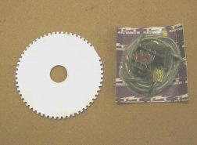
This pick-up fires a bank of 4 ignition coils. Each coil has a dual secondary (two plug wires) that fires two plugs. The valve timing is such that one cylinder is on the compression stroke while the other is on the exhaust stroke. The advance curve is handled electrically and you have dials on a control panel to dial in the advance through several RPM ranges. Thus you can optimize the advance curve to match your particular engine. One of the dials is a rev limiter adjustment. A MAP sensor handles manifold pressure changes.
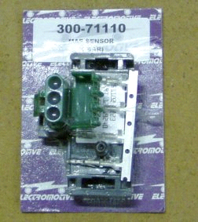
(I have modified my Electromotive system, not for function but just for looks as I am going to “Show” my GT and I wanted the plug wires to come out evenly on each side.)
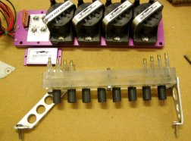

An optional timing control can be mounted inside the cockpit to keep a fine trimmer on timing when conditions change. (temp, fuel etc)
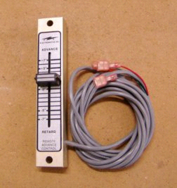
How do I know what to set the adjustable timing to?
I use an LED display from a knock sensor system made by MSD. The knock sensor sends a signal to the display of LEDs. This way, no matter what the present conditions are, I can keep the ignition timing to an optimum by reading the LED display and setting the timing to it’s optimum. The MSD knock censor can read detonation and give me a display when I can not hear any detonation. This is especially true at high RPM. Detonation (abnormal combustion) can destroy an engine in just a few minutes of high RPM running.
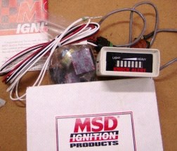
Read my “Tech tip” on ignition on my website,
http://mg-tri-jag.net/tech6.htm

I am using 4 2brl. Downdraft Webers from a 308 Ferrari mounted on my own design sand cast manifolds.
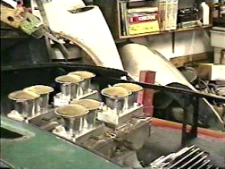
If you are into fuel injection you will find that Electromotive has a cool system that handles fuel control also.
Another goody for tuning is “G-Tech Pro”. This is a small accelerometer with a small computer that can measure horse power just by you weighing your car and making a few full throttle runs. I seen one of these units in use in a friends car a few years ago. It was a turbo charged aluminum block 350 Chevy in an old Datsun PU. My friend “Oz” had the engine on a dyno and knew what it should show as horse power and after three runs and an average showed very close to what the dyno had shown earlier. This unit comes in two versions, “The G-Tech Pro and the G-Tech Pro Competition”.
The Competition model can interface with a laptop. The cost of this unit is less than a connection and a few dyno pulls on an engine dyno. The standard unit is about half of that. I ran across the older version of the standard model and purchased it as I knew it was a supper tuning tool.
I use to race motorcycles professionally and didn’t have such tools so I had to make high speed test runs on a straight highway. (much more dangerous than racing on a race track)
With a G-Tech Pro unit you can make all of your tests and not spin a wheel nor go over the highway speed limit. Cool!!!! These units can also check “G” force in turns so you auto crossers can tune the tire/suspension system too.
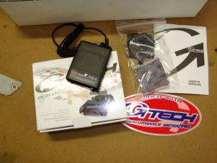

Howard Fitzcharles

MGs, Triumphs & Jaguars

http://mg-tri-jag.net

